Using … at top of the page is importing the namespaces required.
Then under that I define a new namespace
Then define a class e.g. public class ExtentReport.

TestRunSettings.runsettings
XML document. Which is my configuration file for the test run settings for my web automation framework.
<?xml version="1.0" encoding="utf-8" ?>: This is the XML declaration, specifying the version of XML being used (1.0) and the character encoding (UTF-8).
<RunSettings>: This is the root element of the XML document. It contains the configuration settings for the test run.
<TestRunParameters>: This is a section within <RunSettings> that contains specific parameters related to the test run.
<Parameter name="BaseUrl" value="https://www.saucedemo.com/" />: This line defines a parameter named "BaseUrl" with the value "https://www.saucedemo.com/". This represents the base URL of the application that is being tested.
<Parameter name="Browser" value="Chrome" />: This line defines a parameter named "Browser" with the value "Chrome". It indicates the browser in which the tests will be executed. Possible values include "Chrome," "Firefox," "ChromeDocker," and "FirefoxDocker."

ExtentReport.cs
The provided code appears to be a C# class (ExtentReport) that manages the configuration and generation of ExtentReports, which is a reporting library used in test automation. The code also includes methods for initializing, tearing down, and adding screenshots to the reports.
Namespaces:
The code includes several using statements to import namespaces. These are required for using specific classes and functionalities, such as ExtentReports, WebDriver, and file-related operations.
Class and Nested Class:
ExtentReport is a C# class that encapsulates functionality related to generating ExtentReports for test automation.
Inside ExtentReport, there's a nested class AppInfo that defines properties for storing application information (specifically, BaseUrl and Browser).
Static Fields:
The class contains static fields _extentReports, _feature, and _scenario to store instances of ExtentReports and ExtentTest, which are part of the ExtentReports library.

Utility Methods:
GetTestResultPath: A method to get the path where test results, particularly screenshots, will be stored.
DeleteOldScreenshots: A method to delete old screenshot files from the test result path.
ExtentReport Initialization:
ExtentReportInit: A method to initialize the ExtentReports framework. It configures an HTML reporter, specifies report file paths, starts the HTML reporter, and adds system information to the reports.
ExtentReport Tear Down:
ExtentReportTearDown: A method to flush and close the ExtentReports instance. It is typically called at the end of test execution.
Adding Screenshots to the Report:
AddScreenshot: A method to capture a screenshot using the WebDriver (IWebDriver), convert it to a byte array, and save it to a file. The file location is based on the scenario title and is returned for potential use.
This class is designed to provide a centralized way to manage and generate ExtentReports for test automation, including capturing and adding screenshots to the reports. It assumes the usage of the ExtentReports library for reporting purposes and integrates with Selenium for capturing screenshots. The code also uses some features introduced in C# 8.0, such as nullable reference types (string?).

Login.cs
The WebDriver instance for browser automation.

Inventory.cs
Could add:
``` using FluentAssertions;
using OpenQA.Selenium;

namespace NathansWebAutomationFramework.Application.Pages
{
// Represents the Inventory Page of the application
public class Inventory
{
private readonly IWebDriver driver;
public Inventory(IWebDriver driver)
{
this.driver = driver;
}

// Locating specific elements on the page - if changed, can change here
readonly By inventoryTitle = By.ClassName("title");
readonly By cartBtn = By.ClassName("shopping_cart_link");
readonly By prodPrice = By.ClassName("inventory_item_price");
readonly By prodName = By.ClassName("inventory_item_name");

public void FindTitle()
{
IWebElement titleElement = driver.FindElement(inventoryTitle);
string actualTitle = titleElement.Text;
string expectedTitle = "Products"; // Expected title

actualTitle.Should().Be(expectedTitle, "Inventory page title mismatch");
}

public void AddProductCart(string product)
{
driver.FindElement(By.XPath($"//*[@id='add-to-cart-{product}']")).Click();
}

public void ClickCartBtn()
{
driver.FindElement(cartBtn).Click();
}

public void ProductPrice(decimal expectedPrice)
{
decimal actualPrice = Convert.ToDecimal(driver.FindElement(prodPrice).Text);
actualPrice.Should().Be(expectedPrice, "Product price mismatch");
}

public void ProductName(string expectedProductName)
{
string actualProductName = driver.FindElement(prodName).Text;
actualProductName.Should().Be(expectedProductName, "Product name mismatch");
}
}
}

Then change:
``` using FluentAssertions;
using TechTalk.SpecFlow;

namespace NathansWebAutomationFramework.Tests.StepDefinitions
{
[Binding]
public class InventorySteps
{
// ... existing code ...

[Then(@"the (.*) of the (.*) will be correct")]
public void ThenThePriceOfTheProductWillBeCorrect(decimal expectedPrice, string expectedProductName)
{
decimal actualPrice = Convert.ToDecimal(driver.FindElement(prodPrice).Text);
actualPrice.Should().Be(expectedPrice, "Product price mismatch");

string actualProductName = driver.FindElement(prodName).Text;
actualProductName.Should().Be(expectedProductName, "Product name mismatch");
}
}
}

Cart.cs
Could add:
``` public void ClickCheckout()
{
try
{
driver.FindElement(checkout).Click();
}
catch (NoSuchElementException ex)
{
// Handle exception or log an error message
Console.WriteLine($"Error clicking 'Checkout' button: {ex.Message}");
throw; // Rethrow the exception to indicate the failure
}
}

CheckoutStepOne.cs
Could add:
``` public void ClickContinue()
{
try
{
driver.FindElement(continueBtn).Click();
}
catch (NoSuchElementException ex)
{
// Handle exception or log an error message
Console.WriteLine($"Error clicking Continue button: {ex.Message}");
throw; // Rethrow the exception to indicate the failure
}
}

CheckoutStepTwo.cs
Could add:
``` public void ClickFinish()
{
try
{
driver.FindElement(finishBtn).Click();
}
catch (NoSuchElementException ex)
{
// Handle exception or log an error message
Console.WriteLine($"Error clicking Finish button: {ex.Message}");
throw; // Rethrow the exception to indicate the failure
}
}

CheckoutComplete.cs
Could add:
``` public string GetCheckoutCompleteMessage()
{
try
{
return driver.FindElement(checkoutCompleteMsg).Text;
}
catch (NoSuchElementException ex)
{
// Handle exception or log an error message
Console.WriteLine($"Error retrieving checkout completion message: {ex.Message}");
throw; // Rethrow the exception to indicate the failure
}
}

DriverManager.cs
Initialization of WebDriver (Init method):
Accepts the browser type (Chrome, Firefox, ChromeDocker, FirefoxDocker) and URL parameters.
Prints a message indicating the initialization with the specified browser and URL.
Uses a switch statement to configure the driver based on the provided browser type.
For Chrome and Firefox, it adds an argument for headless mode. For ChromeDocker and FirefoxDocker, it connects to a Selenium Grid.
Initializes the driver accordingly.
Navigation to URL (GoTo method):

Takes a URL parameter and navigates the driver to that URL.
Getting the Current WebDriver Instance (GetDriver method):

Returns the current instance of the IWebDriver or null if not initialized.
Closing WebDriver Instance (CloseDriver method):

Quits the WebDriver instance and sets it to null.
Overall, your class is handling WebDriver initialization, navigation, and cleanup in a modular way. It accommodates different browsers and includes additional configurations for headless mode and Docker scenarios. The use of Console.WriteLine for logging is good for debugging purposes. If this code meets your requirements and runs successfully, it seems well-written.

Hooks.cs
This class is a set of hooks for SpecFlow, a framework for behavior-driven development (BDD). Hooks are methods with attributes that are executed at specific points in the execution lifecycle of a SpecFlow scenario.
Here's a breakdown of the key functionality:
Constructor (Hooks(IObjectContainer container))
It takes an IObjectContainer as a parameter. This is part of SpecFlow's dependency injection mechanism, which allows sharing objects between different parts of the SpecFlow runtime.
The container is stored in a private field _container for later use.

BeforeTestRun
Executed before the entire test run.
Retrieves base URL and browser from TestContext.Parameters.
Constructs the Selenium Grid URL based on the Docker network.
Creates an instance of AppInfo and sets properties.
Calls ExtentReportInit with the created AppInfo and Selenium Grid URL.

AfterTestRun
Executed after the entire test run.
Calls ExtentReportTearDown.

BeforeFeature
Executed before each feature.
Retrieves the feature context and creates an Extent Report node for the feature.

FirstBeforeScenario
Executed before each scenario.
Retrieves browser and base URL from TestContext.Parameters.
Initializes WebDriver using DriverManager.
Registers WebDriver instance with the BoDi container.
In SpecFlow, the BoDi (Behavior-Driven Development) container is a dependency injection (DI) container used to manage the lifecycle and sharing of objects across different parts of the SpecFlow runtime. It allows you to register and resolve instances of objects, promoting a more modular and maintainable design.
In the context of the provided code, the line:
csharp
_container.RegisterInstanceAs<IWebDriver>(DriverManager.GetDriver());
registers an instance of the IWebDriver interface with the BoDi container. This means that the WebDriver instance created by DriverManager.GetDriver() will be available for injection into other parts of your SpecFlow test execution that request an IWebDriver instance through dependency injection.
Later in the code or in other classes that have access to the same BoDi container, you can use:
var webDriver = _container.Resolve<IWebDriver>();
This line resolves (or retrieves) the previously registered IWebDriver instance from the BoDi container. This mechanism ensures that the same WebDriver instance is shared among different parts of your SpecFlow scenario execution, promoting consistency and avoiding the need to create multiple WebDriver instances.
Creates an Extent Report node for the scenario.
In the provided code, the line:
_scenario = _feature.CreateNode<Scenario>(scenarioContext.ScenarioInfo.Title);
is creating an Extent Report node for the current SpecFlow scenario. Extent Reports is a reporting library commonly used for generating interactive and detailed HTML reports in test automation.
Explanation of the code:
_feature: This represents the Extent Report node for the current feature. It's a higher-level node that encompasses all scenarios within that feature.
.CreateNode<Scenario>(scenarioContext.ScenarioInfo.Title): This method creates a child node under the feature node specifically for the current scenario. The type parameter <Scenario> specifies the type of node to be created, and scenarioContext.ScenarioInfo.Title provides the title or name of the scenario.
This Extent Report node serves as a container for logging information related to the execution of the scenario. As the scenario progresses, you can log various details, steps, and status updates to this node, and it will be reflected in the generated Extent Report. For example, if a step fails, a screenshot may be attached to this scenario node to provide visual evidence of the failure.

AfterScenario
Executed after each scenario.
Closes the WebDriver.
Calls ExtentReportTearDown.
AfterStep
Executed after each step.
Retrieves information about the executed step.
Captures and attaches a screenshot to the Extent Report if the scenario fails.
Creates nodes based on the step type (Given, When, Then, And).
The code snippet:
// Create nodes based on step type (Given, When, Then, And)
if (stepType == "Given")
{
_scenario.CreateNode<Given>(stepName);
}
else if (stepType == "When")
{
_scenario.CreateNode<When>(stepName);
}
else if (stepType == "Then")
{
_scenario.CreateNode<Then>(stepName);
}
else if (stepType == "And")
{
_scenario.CreateNode<And>(stepName);
}
is creating nodes in the Extent Report based on the type of Gherkin step (Given, When, Then, And) that is being executed in a SpecFlow scenario.
Explanation:
stepType: This variable holds the type of the Gherkin step. In SpecFlow, Gherkin steps are categorized as Given, When, Then, or And based on their purpose in the scenario.
stepName: This variable holds the text or description of the Gherkin step.
The code checks the type of the Gherkin step (stepType) and then creates a corresponding node in the Extent Report. Each type of step (Given, When, Then, And) is associated with a specific node type in the Extent Report:

If the step is of type "Given," it creates a Given node.
If the step is of type "When," it creates a When node.
If the step is of type "Then," it creates a Then node.
If the step is of type "And," it creates an And node.
These nodes in the Extent Report represent the execution of individual Gherkin steps in the SpecFlow scenario. They help organize and categorize the information in the report, making it more readable and informative. The status and details of each step can be logged to these nodes during the execution of the scenario.
In summary, this class manages the setup and teardown tasks related to the test execution, integrates with the Extent Report for reporting, and provides context-aware actions at various points in the SpecFlow lifecycle.

NODES
In the context of Extent Reports, a "node" refers to a unit of information or a container that holds information about a specific test or a step within a test. It's a way of organizing and presenting information in a hierarchical manner within the Extent Report.
Extent Reports are commonly used for reporting in automated testing frameworks. They provide detailed information about test execution, including pass/fail status, test steps, and additional details. Here's how the concept of nodes typically works:
Test Node: Represents an entire test case or scenario. Each test case is often considered a "node" in the Extent Report. It includes information about the overall status of the test, any associated logs, screenshots, etc.
Step Node: Represents an individual step within a test case. For example, a Gherkin step like Given, When, Then, or And would be represented by a step node. These nodes capture information about the execution of each step.
Hierarchical Structure: Extent Reports often have a hierarchical structure where test nodes can contain multiple step nodes. This structure helps in organizing information and presenting it in a logical manner.
Here's a simplified example:
Test Case 1
├── Step 1 (Given)
├── Step 2 (When)
└── Step 3 (Then)
In this example, "Test Case 1" is a test node, and each step (Given, When, Then) is a step node. The hierarchical structure provides a clear representation of the flow of the test case and the details associated with each step.
When you create nodes in Extent Reports using code, you're essentially adding structured information to the report, making it more readable and informative. Each node can include additional details such as logs, screenshots, and other relevant information to help diagnose issues during test execution.

LoginSteps.cs
// Get the WebDriver instance from the DriverManager
this.driver = DriverManager.GetDriver();

// Create an instance of the Login page object
this.login = new Login(driver);

Inventory.Cs
public InventorySteps()
{
// Get the WebDriver instance from the DriverManager
this.driver = DriverManager.GetDriver();

// Create an instance of the Inventory page object
this.inventory = new Inventory(driver);
}

CheckoutStepTwoStep
public CheckoutStepTwoStep()
{
// Get the WebDriver instance from the DriverManager
this.driver = DriverManager.GetDriver();

// Create an instance of the CheckoutStepTwo page object
this.checkoutStepTwo = new CheckoutStepTwo(driver);
}

CheckoutStepOneStep.cs
public CheckoutStepOneStep()
{
// Get the WebDriver instance from the DriverManager
this.driver = DriverManager.GetDriver();

// Create an instance of the CheckoutStepOne page object
this.checkoutStepOne = new CheckoutStepOne(driver);
}

CheckoutStepCompleteStep.cs
public CheckoutCompleteStep()
{
// Get the WebDriver instance from the DriverManager
this.driver = DriverManager.GetDriver();

// Create an instance of the CheckoutComplete page object
this.checkoutComplete = new CheckoutComplete(driver);
}

CartStep.cs
public CartStep()
{
// Get the WebDriver instance from the DriverManager
this.driver = DriverManager.GetDriver();

// Create an instance of the Cart page object
this.cart = new Cart(driver); }

Certainly! Based on the snippets and explanations provided, here's a summary of the SpecFlow BDD .NET web automation framework:
Page Objects:
The framework employs a Page Object Model (POM) approach, where each web page is represented by a corresponding class (e.g., Inventory, Login, CheckoutStepOne, etc.).
The page classes encapsulate the interactions and elements of their respective pages.

Step Definitions:
Step definition classes (e.g., LoginSteps, InventorySteps, etc.) contain the automation steps corresponding to the Gherkin scenarios.
These classes use the Page Object instances to perform actions on the web pages and verify expected outcomes.

Driver Management:
The DriverManager class handles WebDriver initialization (Init method), navigation (GoTo method), and closure (CloseDriver method).
It supports various browsers and can be configured for headless mode or Selenium Grid.

Hooks:
The Hooks class contains methods annotated with SpecFlow attributes ([BeforeTestRun], [AfterTestRun], [BeforeFeature], [BeforeScenario], [AfterScenario], [AfterStep]).
It initializes and tears down the Extent report, sets up the WebDriver before scenarios, and captures screenshots after steps.

Extent Reporting:
Extent reporting is integrated into the framework, providing detailed reports on test execution.

BoDi Container:
The IObjectContainer is used to manage dependency injection, particularly for sharing the WebDriver instance (IWebDriver) across different steps.

FluentAssertions:
The FluentAssertions library is utilized for more readable and expressive assertions in the test steps.

NUnit Integration:
The framework integrates with NUnit for test execution.

Selenium and SpecFlow:
The framework uses Selenium WebDriver for browser automation and SpecFlow for behavior-driven development.

Configuration:
Configuration parameters, such as base URL and browser, are retrieved from TestContext.Parameters.

Scenario Organization:
Scenarios are organized in feature files using Gherkin syntax, and corresponding step definitions are implemented in step definition classes.

Exception Handling:
Exception handling is implemented to capture and report errors, including taking screenshots for failed steps.

In summary, the framework follows best practices in test automation, leveraging SpecFlow for behavior-driven development, Selenium WebDriver for browser automation, and integrating additional tools and libraries for reporting and maintainability. It emphasizes modularity, readability, and ease of maintenance through the use of the Page Object Model.

GitHub actions:
Certainly! Configuring continuous integration (CI) with GitHub Actions involves creating a workflow file in your repository. Below is a simplified example to get you started. This example assumes you are using NUnit for your tests. Adjustments might be needed based on your exact setup.

Create a Workflow File:
Create a new file in your repository under the path .github/workflows/main.yml. This file will define the workflow for GitHub Actions.

yaml
Copy code
name: CI

on:
push:
branches:
- main

jobs:
build:
runs-on: ubuntu-latest

steps:
- name: Checkout code
uses: actions/checkout@v2

- name: Setup .NET
uses: actions/setup-dotnet@v2
with:
dotnet-version: '6.0.100-preview.6'

- name: Restore dependencies
run: dotnet restore

- name: Build
run: dotnet build --configuration Release

- name: Run Tests
run: dotnet test --configuration Release --no-build
This workflow is triggered on every push to the main branch. It checks out the code, restores dependencies, builds the solution, and runs tests.

Add NUnit Test Results Reporting:
To generate and publish NUnit test results, you can use a GitHub Action like reportgenerator. Add the following steps to the workflow:

yaml
Copy code
- name: Run Tests and Generate Report
run: |
dotnet test --configuration Release --no-build --logger "nunit;LogFilePath=test-results.xml"
dotnet tool install -g dotnet-reportgenerator-globaltool
reportgenerator -reports:./YourProject.Tests/TestResults/test-results.xml -targetdir:./coverage -reporttypes:Html

- name: Publish Test Results
uses: actions/upload-artifact@v2
with:
name: test-results
path: ./coverage
This step runs the tests, generates an HTML coverage report, and publishes it as an artifact.

Viewing Results:
Once the workflow runs, you can view the results on the GitHub Actions tab in your repository. You'll see the status of each job, and you can click on individual jobs to see the details, including test results.

Additionally, you can add badges to your README file to display the build status. For example:

markdown
Copy code
![Build Status](https://github.com/YourUsername/YourRepository/workflows/CI/badge.svg)
Scheduled Runs:
To set up scheduled runs, you can create a new workflow specifically for scheduled runs. Add a new YAML file under .github/workflows/scheduled.yml. You can set the schedule based on your needs:

yaml
Copy code
name: Scheduled Tests

on:
schedule:
- cron: '0 0 * * *'

jobs:
run-tests:
runs-on: ubuntu-latest

steps:
- name: Checkout code
uses: actions/checkout@v2

- name: Setup .NET
uses: actions/setup-dotnet@v2
with:
dotnet-version: '6.0.100-preview.6'

- name: Restore dependencies
run: dotnet restore

- name: Run Tests
run: dotnet test --configuration Release --no-build
In this example, the tests will run every day at midnight.

Remember to adjust the workflow files based on your specific project structure and test configuration.

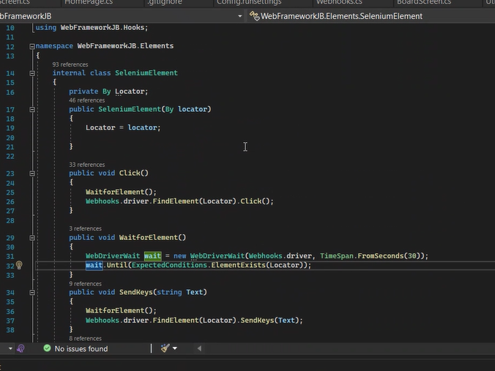
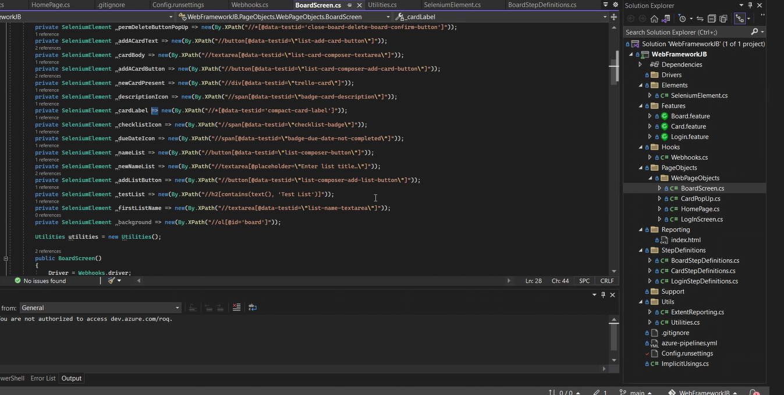
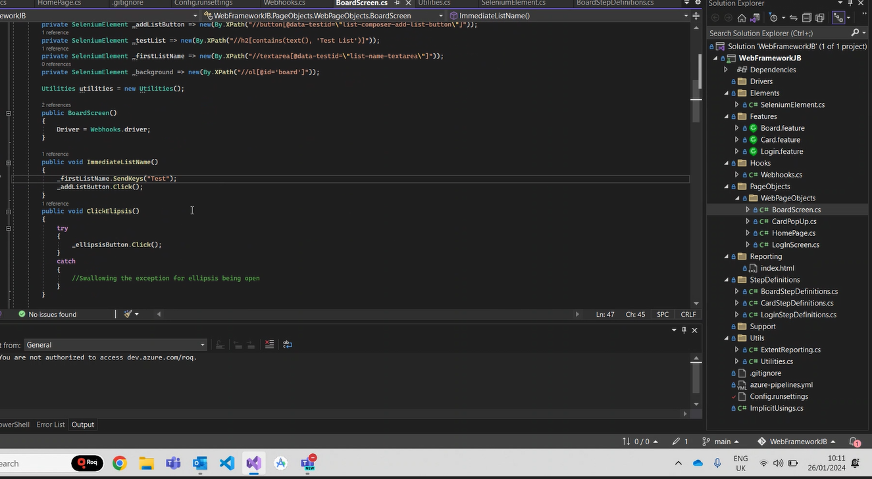
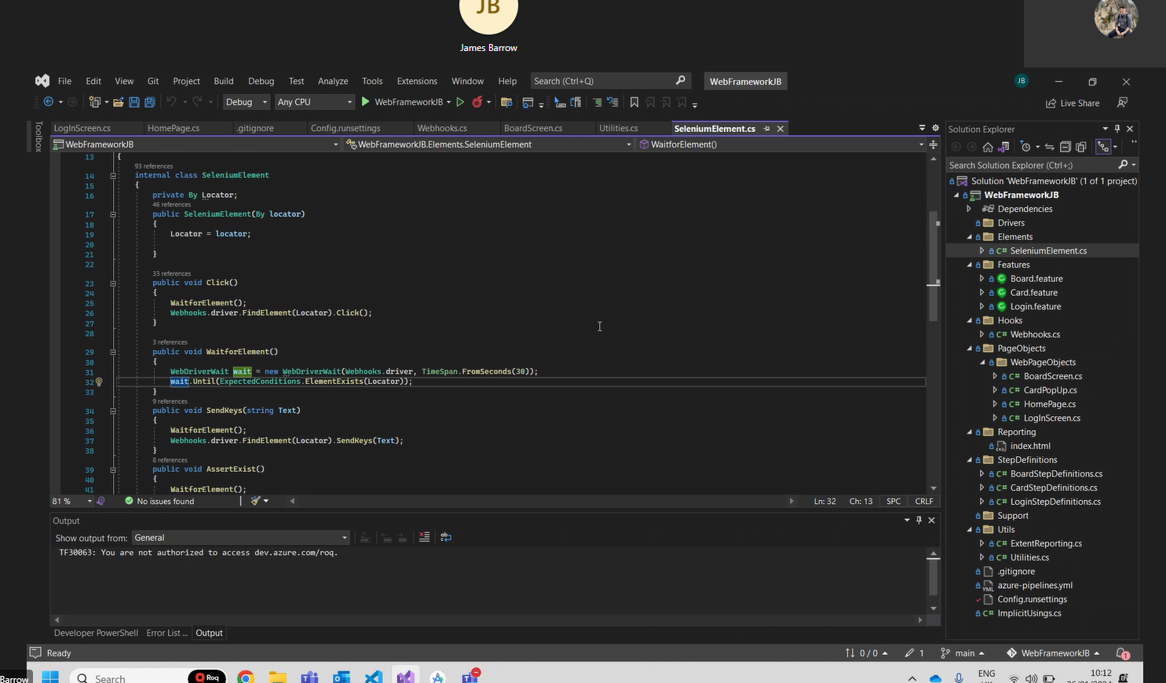
Move folder back.
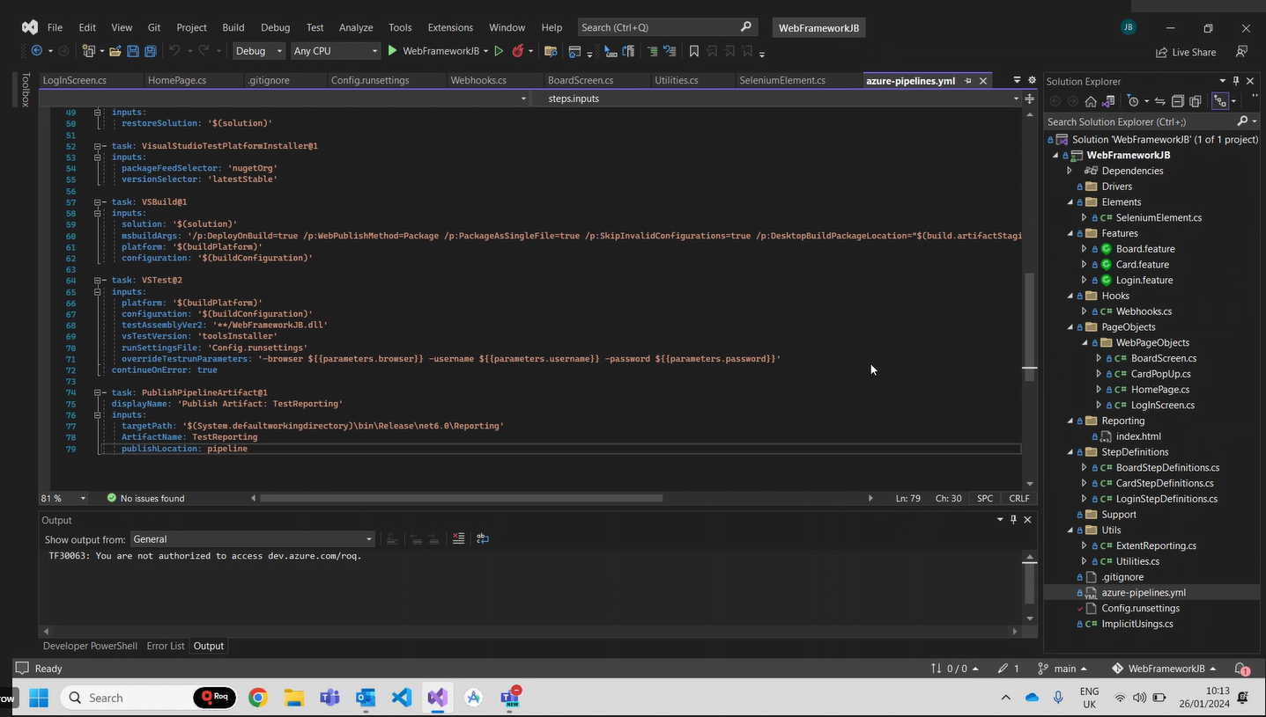
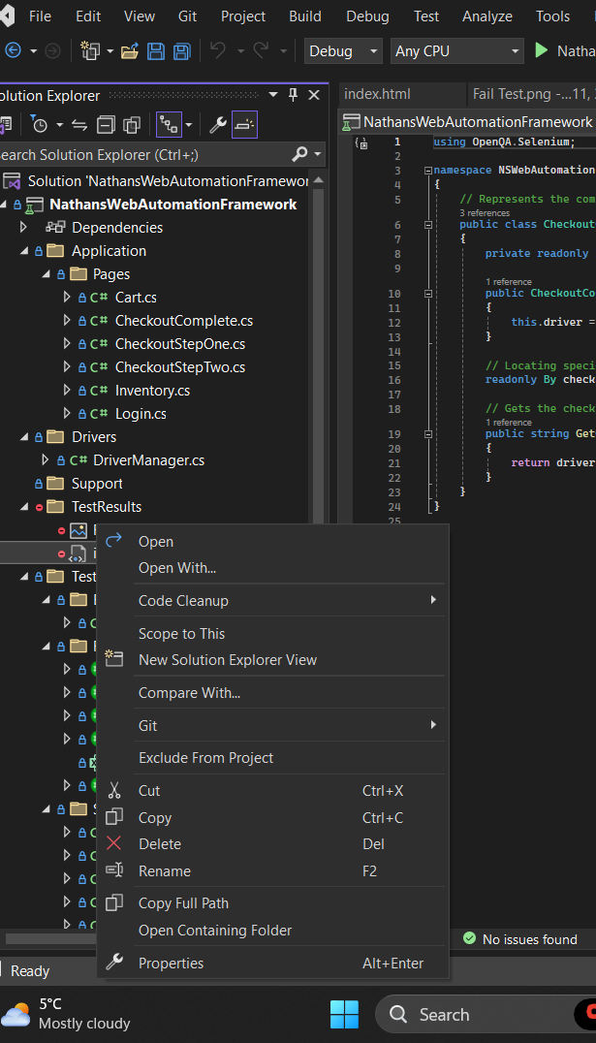
ADDED MY OWN ELEMENT WRAPPER:
Explanation of ElementWrapper Class:
Constructor:
public ElementWrapper(IWebDriver driver, By by)
Initializes an instance of the ElementWrapper class with an IWebDriver instance and a By object, representing the method used to locate the element.

FindElement Method:
public IWebElement FindElement()
Uses a WebDriverWait to wait for the element to be present before attempting to find it.
Throws a WebDriverTimeoutException if the element is not found within the specified timeout.
Returns the found IWebElement.

Click Method:
public void Click()
Calls FindElement() to locate the element and then performs a click on it.

SendKeys Method:
public void SendKeys(string text)
Calls FindElement() to locate the element and then sends the specified keys to it.

GetText Method:
public string GetText()
Calls FindElement() to locate the element and then retrieves its text.

Could do:
```using OpenQA.Selenium;
using OpenQA.Selenium.Support.UI;
using System;

namespace NathansWebAutomationFramework.Application.Elements
{
public class ElementWrapper
{
private readonly IWebDriver driver;
private readonly By by;

public ElementWrapper(IWebDriver driver, By by)
{
this.driver = driver;
this.by = by;
}

public IWebElement FindElement()
{
try
{
var wait = new WebDriverWait(driver, TimeSpan.FromSeconds(10));
return wait.Until(driver => driver.FindElement(by));
}
catch (StaleElementReferenceException)
{
// Retry finding the element
return FindElement();
}
catch (WebDriverTimeoutException)
{
Console.WriteLine($"Timeout waiting for the element to be visible: {by}");
throw;
}
}

public void Click()
{
FindElement().Click();
}

public void SendKeys(string text)
{
FindElement().SendKeys(text);
}

public string GetText()
{
return FindElement().Text;
}

public void Clear()
{
FindElement().Clear();
}

public bool IsDisplayed()
{
try
{
return FindElement().Displayed;
}
catch (NoSuchElementException)
{
return false;
}
}

public bool IsEnabled()
{
try
{
return FindElement().Enabled;
}
catch (NoSuchElementException)
{
return false;
}
}

// Add more methods as needed, such as Select, GetAttribute, etc.
}
}

The ElementWrapper class looks fine and is well-structured. It encapsulates the common Selenium operations and adds a layer of abstraction by handling waits for the element to be present before performing actions. This promotes more robust and stable test automation.
Make sure to thoroughly test the interactions with different types of elements in your application to ensure that the ElementWrapper is handling various scenarios effectively.
If you encounter specific scenarios where additional functionality or modifications are needed, you can always extend or modify the ElementWrapper class accordingly. But as a foundation for handling basic interactions with web elements, the current implementation is good.

CI CD - 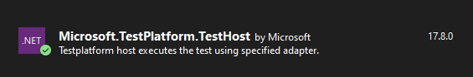
Allows for test to run on machines without Visual studio

If get error maybe add quotes here:
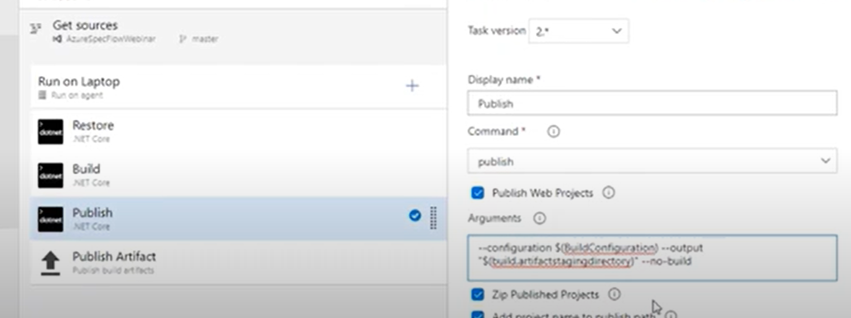
Checkout code from repo/ project
Restored any dependencies
Building the project
Publishing the project

Checkout code,
Nuget restore,
Build project,
Publishing project,
Now running tests.
Publishing results
Miss failure: in VS TEST 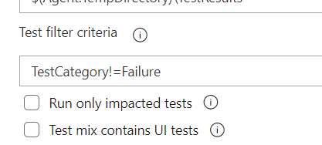
Schedlule test in triggers

This code defines a class named ElementWrapper that serves as a wrapper around Selenium's IWebDriver and By classes to simplify common interactions with web elements. Let's break down the key components:
- Constructor: The class has a constructor that takes an IWebDriver instance and a By instance. These parameters represent the Selenium WebDriver and the method of locating the HTML element, respectively.
csharpCopy code
public ElementWrapper(IWebDriver driver, By by) { this.driver = driver; this.by = by; }
- FindElement and FindElements Methods: These methods are used to locate a single element or multiple elements on the web page based on the provided By strategy. They use WebDriverWait to wait for the elements to be present before attempting to find them. If the element(s) are not found within a specified timeout, a WebDriverTimeoutException is caught, and an error message is printed.
csharpCopy code
public IWebElement FindElement() { // ... } public IReadOnlyCollection<IWebElement> FindElements() { // ... }
- Clear, Click, SendKeys Methods: These methods provide simplified ways to interact with the web elements. They internally use FindElement() to locate the element before performing the desired action.
csharpCopy code
public void Clear() { FindElement().Clear(); } public void Click() { FindElement().Click(); } public void SendKeys(string text) { FindElement().SendKeys(text); }
- GetText Method: This method retrieves the text content of a web element using FindElement().
csharpCopy code
public string GetText() { return FindElement().Text; }
This class encapsulates common Selenium actions, making it easier to write concise and readable automation code. It follows the Page Object Model (POM) pattern by providing a higher-level abstraction for interacting with web elements.

This code defines a class named Inventory, which represents the Inventory Page of a web application. Let's break down the key components:
- Constructor: The class has a constructor that takes an IWebDriver instance, representing the Selenium WebDriver used for interacting with the web page.
csharpCopy code
public Inventory(IWebDriver driver) { this.driver = driver; }
- Locating Elements: The class contains private properties that use the ElementWrapper class to locate specific elements on the page. These properties represent elements like the inventory title, cart button, product price, product name, and a dynamic product element.
csharpCopy code
private ElementWrapper InventoryTitle => new ElementWrapper(driver, By.ClassName("title")); private ElementWrapper CartButton => new ElementWrapper(driver, By.ClassName("shopping_cart_link")); private ElementWrapper ProductPrice => new ElementWrapper(driver, By.ClassName("inventory_item_price")); private ElementWrapper ProductName => new ElementWrapper(driver, By.ClassName("inventory_item_name")); private ElementWrapper ProductElement(string product) => new ElementWrapper(driver, By.XPath($"//*[@id='add-to-cart-{product}']"));
- FindTitle Method: This method verifies the title of the inventory page by comparing the actual title with the expected title. If they don't match, it throws an exception.
csharpCopy code
public void FindTitle() { // ... }
- AddProductToCart Method: This method adds a specified product to the cart by clicking the "add-to-cart" button for that product.
csharpCopy code
public void AddProductToCart(string product) { // ... }
- ClickCartButton Method: This method clicks on the cart button.
csharpCopy code
public void ClickCartButton() { CartButton.Click(); }
- VerifyProductPrice Method: This method verifies the price of a product by comparing the actual prices of the products on the page with the expected price. It uses NUnit assertions for the comparison.
csharpCopy code
public void VerifyProductPrice(decimal expectedPrice) { // ... }
- VerifyProductName Method: This method verifies the name of a product by comparing the actual names of the products on the page with the expected name. It uses NUnit assertions for the comparison.
csharpCopy code
public void VerifyProductName(string expectedProduct) { // ... }
These methods encapsulate the logic for interacting with elements on the inventory page, making the code more modular and readable. The ElementWrapper class is used for handling common actions with web elements. The methods also include error handling and exception throwing for cases where the expected conditions are not met.

Certainly! Let's break down each of these methods:
- VerifyProductPrice:
csharpCopy code
public void VerifyProductPrice(decimal expectedPrice) { var productPrices = new List<IWebElement>(ProductPrice.FindElements()); for (int i = 0; i < productPrices.Count; i++) { string actualPriceText = productPrices[i].Text; // Remove currency symbols, whitespaces, and any other non-numeric characters actualPriceText = Regex.Replace(actualPriceText, @"[^\d.]", ""); if (decimal.TryParse(actualPriceText, out decimal actualPrice)) { // Use NUnit assertion to check if the actual price matches the expected price if (actualPrice == expectedPrice) { return; // Found a match, exit the loop } } } // If no match is found, throw an exception throw new AssertionException($"No matching product price found for {expectedPrice}"); }
  - Explanation:
    - This method verifies the price of a product on the page.
    - It retrieves a list of IWebElement representing the product prices using the ProductPrice element.
    - It then iterates through each product price and performs the following steps:
      - Extracts the text of the product price.
      - Removes any non-numeric characters, including currency symbols and whitespaces.
      - Parses the cleaned text into a decimal (actualPrice).
      - Compares the actualPrice with the expectedPrice using NUnit assertion.
      - If a match is found, the method returns, indicating a successful verification.
    - If no match is found after iterating through all product prices, it throws an AssertionException indicating that no matching product price was found.
- VerifyProductName:
csharpCopy code
public void VerifyProductName(string expectedProduct) { var productNames = ProductName.FindElements(); foreach (var productNameElement in productNames) { string actualProductName = productNameElement.Text; // Trim extra spaces for comparison string cleanedActualProductName = actualProductName.Trim(); // Use NUnit assertion to check if the cleaned actual product name matches the cleaned expected product name if (cleanedActualProductName.Equals(expectedProduct.Trim(), StringComparison.OrdinalIgnoreCase)) { return; // Found a match, exit the loop } } // If no match is found, throw an exception throw new AssertionException($"No matching product name found for {expectedProduct}"); }
  - Explanation:
    - This method verifies the name of a product on the page.
    - It retrieves a list of IWebElement representing the product names using the ProductName element.
    - It then iterates through each product name and performs the following steps:
      - Extracts the text of the product name.
      - Trims any extra spaces from both the actualProductName and expectedProduct for accurate comparison.
      - Uses NUnit assertion to check if the cleaned actual product name matches the cleaned expected product name.
      - If a match is found, the method returns, indicating a successful verification.
    - If no match is found after iterating through all product names, it throws an AssertionException indicating that no matching product name was found.
In both methods, the use of NUnit assertions ensures that the tests fail with meaningful messages if the expected conditions are not met. These methods provide a clean and structured way to verify product prices and names on the inventory page.

Scheduled Pipeline run in Ado with triggers:
BEST VIDEO FOR SETTING UP PIPELINE - https://www.youtube.com/watch?v=6w440IrjIIM
https://learn.microsoft.com/en-us/azure/devops/pipelines/process/scheduled-triggers?view=azure-devops&tabs=classic
https://www.youtube.com/watch?v=RlZ31mAS_DA
https://learn.microsoft.com/en-us/azure/devops/pipelines/create-first-pipeline?view=azure-devops&WT.mc_id=-blog-shchowd&tabs=net%2Ctfs-2018-2%2Cbrowser
VSTest.Console.exe command-line options | Microsoft Learn

